**2. Develop a Purchase Order form using Html form and Servlet**

**Index:**

<!DOCTYPE html>

<html>

<head>

<title>Purchase Order Form</title>

<meta charset="UTF-8">

<meta name="viewport" content="width=device-width, initial-scale=1.0">

</head>

<body>

<center>

<h1>Purchase Order</h1>

<form action="NewServlet" method="get">

<table>

<tr>

<td>Enter Name:</td>

<td><input type="text" name="name"></td>

</tr>

<tr>

<td>Enter Address:</td>

<td><input type="text" name="address"></td>

</tr>

<tr>

<td>Enter Phone Number:</td>

<td><input type="text" name="phoneN"></td>

</tr>

<tr>

<td>Select the Product:</td>

<td>

<select name="product" id="product">

<option value="product1">Product 1</option>

<option value="product2">Product 2</option>

<option value="product3">Product 3</option>

</select>

</td>

</tr>

<tr>

<td>Enter Quantity:</td>

<td><input type="text" name="quantity"></td>

</tr>

<tr>

<td>Payment Method:</td>

<td>

<select name="payment" id="payment">

<option value="Gpay">Google Pay</option>

<option value="Phone Pay">Phone Pay</option>

<option value="Offline Pay">Offline Pay</option>

</select>

</td>

</tr>

<tr>

<td>Enter Address2:</td>

<td><input type="text" name="address2"></td>

</tr>

<tr>

<td>Enter City:</td>

<td><input type="text" name="city"></td>

</tr>

<tr>

<td>Enter State:</td>

<td><input type="text" name="state"></td>

</tr>

<tr>

<td>Enter Pin Code:</td>

<td><input type="text" name="pcode"></td>

</tr>

<tr>

<td>Enter Country:</td>

<td><input type="text" name="country"></td>

</tr>

<tr>

<td colspan="2">

<br>

<input type="submit" value="Place the Order">

</td>

</tr>

</table>

</form>

</center>

</body>

</html>

**NewServlet.java:**

import java.io.IOException;

import java.io.PrintWriter;

import javax.servlet.ServletException;

import javax.servlet.annotation.WebServlet;

import javax.servlet.http.HttpServlet;

import javax.servlet.http.HttpServletRequest;

import javax.servlet.http.HttpServletResponse;

/**

* Servlet implementation class NewServlet

*/

@WebServlet(urlPatterns = {"/NewServlet"})

public class NewServlet extends HttpServlet {

private static final long serialVersionUID = 1L;

/**

* Processes requests for both HTTP GET and POST methods.

*

* @param request servlet request

* @param response servlet response

* @throws ServletException if a servlet-specific error occurs

* @throws IOException if an I/O error occurs

*/

protected void processRequest(HttpServletRequest request, HttpServletResponse response)

throws ServletException, IOException {

// If you plan to add common logic here, implement it.

}

/**

* Handles the HTTP GET request.

*/

protected void doGet(HttpServletRequest request, HttpServletResponse response)

throws ServletException, IOException {

// Call processRequest if you want shared logic for GET and POST

processRequest(request, response);

// Set the response content type

response.setContentType("text/html;charset=UTF-8");

try (PrintWriter out = response.getWriter()) {

// Retrieve parameters from the form

String name = request.getParameter("name");

String address = request.getParameter("address");

String phoneN = request.getParameter("phoneN");

String quantity = request.getParameter("quantity");

String address2 = request.getParameter("address2");

String city = request.getParameter("city");

String state = request.getParameter("state");

String pcode = request.getParameter("pcode");

String country = request.getParameter("country");

// Output the response in HTML format

out.println("<!DOCTYPE html>");

out.println("<html>");

out.println("<head>");

out.println("<title>Purchase Order Details</title>");

out.println("</head>");

out.println("<body>");

out.println("<h1>Order Summary</h1>");

out.println("<p><strong>Name: </strong>" + name + "</p>");

out.println("<p><strong>Address: </strong>" + address + "</p>");

out.println("<p><strong>Phone Number: </strong>" + phoneN + "</p>");

out.println("<p><strong>Quantity: </strong>" + quantity + "</p>");

out.println("<p><strong>Address 2: </strong>" + address2 + "</p>");

out.println("<p><strong>City: </strong>" + city + "</p>");

out.println("<p><strong>State: </strong>" + state + "</p>");

out.println("<p><strong>Pin Code: </strong>" + pcode + "</p>");

out.println("<p><strong>Country: </strong>" + country + "</p>");

out.println("</body>");

out.println("</html>");

}

}

/**

* Handles the HTTP POST request.

*/

protected void doPost(HttpServletRequest request, HttpServletResponse response)

throws ServletException, IOException {

// Call processRequest if you want shared logic for GET and POST

processRequest(request, response);

}

/**

* Returns a short description of the servlet.

*/

public String getServletInfo() {

return "Servlet that processes a purchase order.";

}

}

**Output**

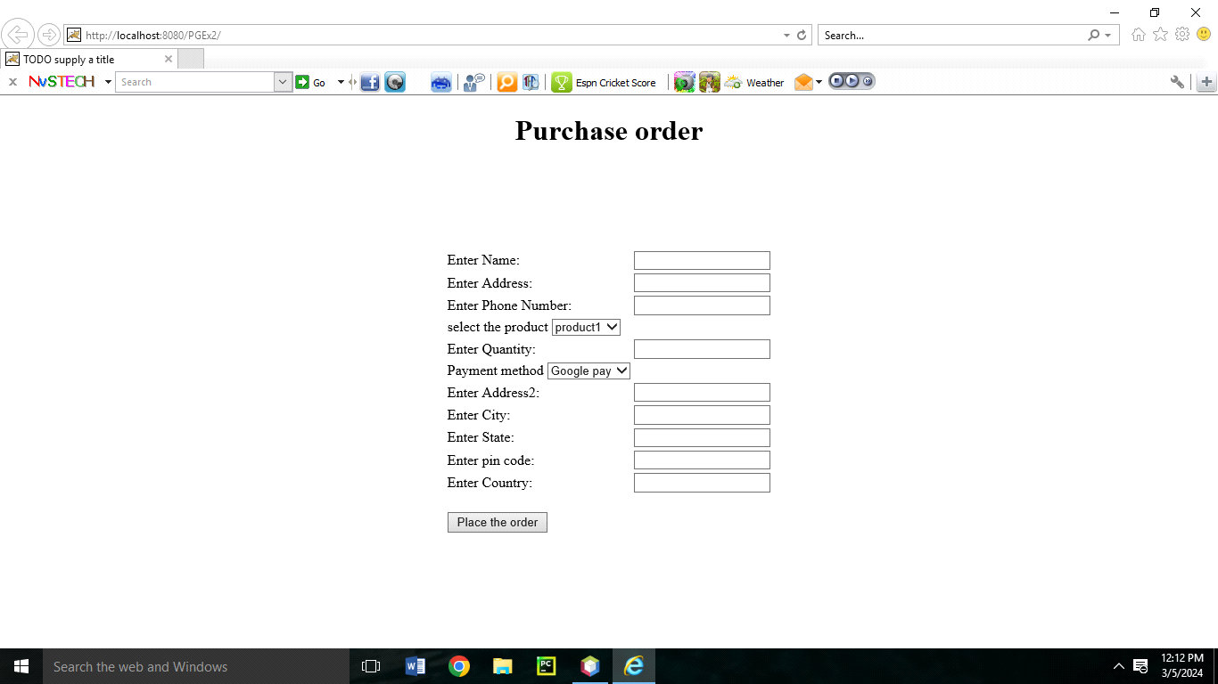

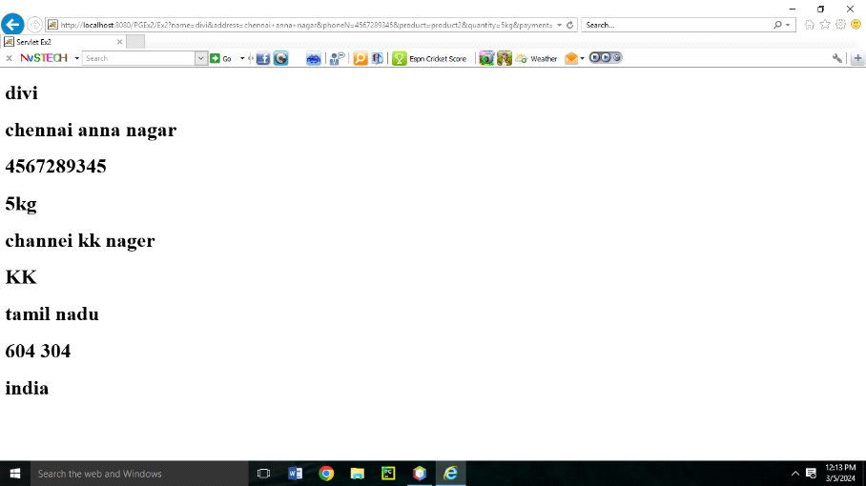

**3. Calculating the percentage of Marks of Student using JSP**

**index.html**

<!DOCTYPE html>

<html>

<head>

<title>Marks Calculation</title>

</head>

<body>

<h2>Enter Marks</h2>

<form action=" Calculating.jsp" method="post">

<label for="m1">Mark 1: </label>

<input type="text" id="m1" name="m1" required><br><br>

<label for="m2">Mark 2: </label>

<input type="text" id="m2" name="m2" required><br><br>

<label for="m3">Mark 3: </label>

<input type="text" id="m3" name="m3" required><br><br>

<input type="submit" value="Submit">

</form>

</body>

</html>

**Calculating.jsp :**

<%@ page import="java.io.*" %>

<%@ page contentType="text/html; charset=UTF-8" %>

<%@ page language="java" %>

<html>

<head>

<title>Marks Calculation</title>

</head>

<body>

<h2>Marks Calculation Result</h2>

<%

// Getting the marks from the form

String m1Param = request.getParameter("m1");

String m2Param = request.getParameter("m2");

String m3Param = request.getParameter("m3");

if (m1Param != null && m2Param != null && m3Param != null) {

try {

// Parsing the marks as integers

int m1 = Integer.parseInt(m1Param);

int m2 = Integer.parseInt(m2Param);

int m3 = Integer.parseInt(m3Param);

// Calculating total and average

int tot = m1 + m2 + m3;

int avg = tot / 3;

// Display the total and average

out.println("<p>The total marks are: " + tot + "</p>");

out.println("<p>The average marks are: " + avg + "</p>");

// Display pass or fail based on the average

if (avg >= 50) {

out.println("<p>Status: Pass</p>");

} else {

out.println("<p>Status: Fail</p>");

}

} catch (NumberFormatException e) {

out.println("<p>Error: Please enter valid numeric values for marks.</p>");

}

} else {

out.println("<p>Error: Missing form data. Please enter marks for all subjects.</p>");

}

%>

</body>

</html>

**Output**

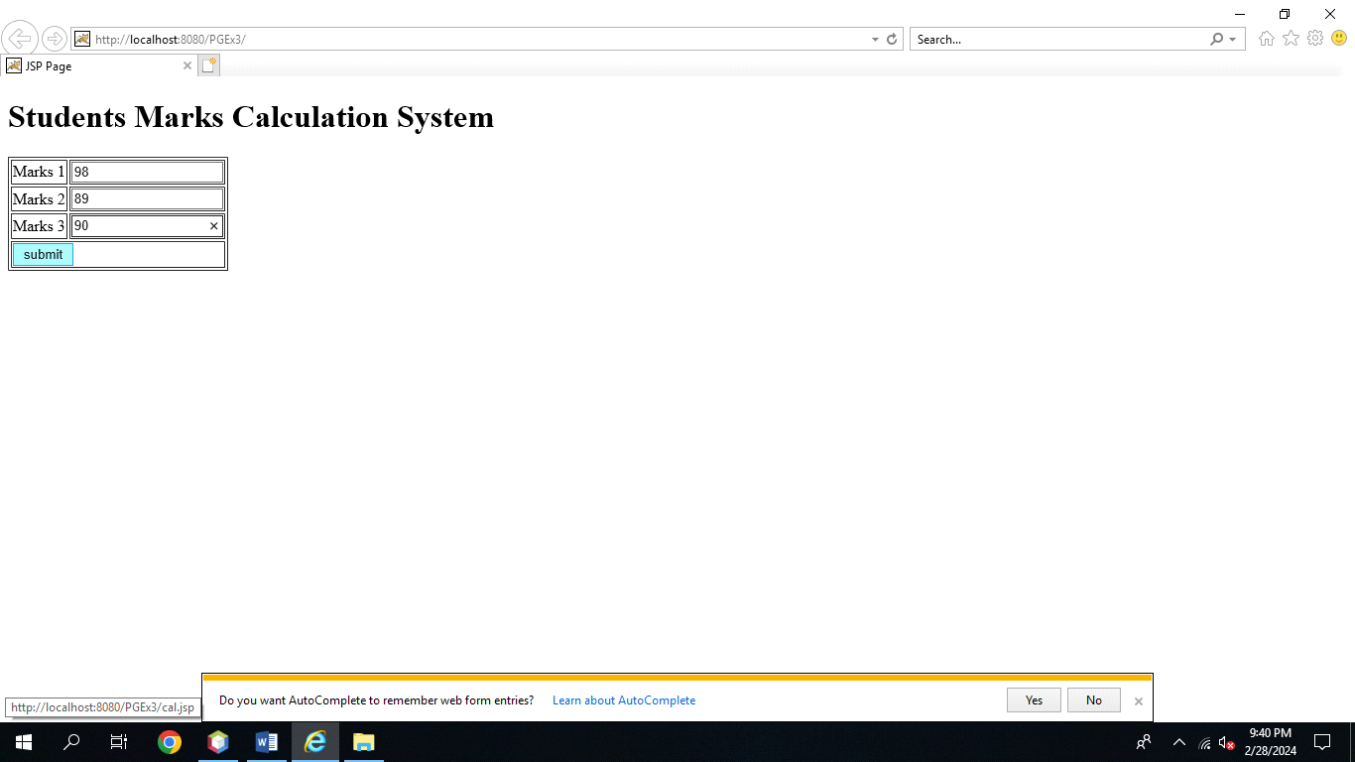

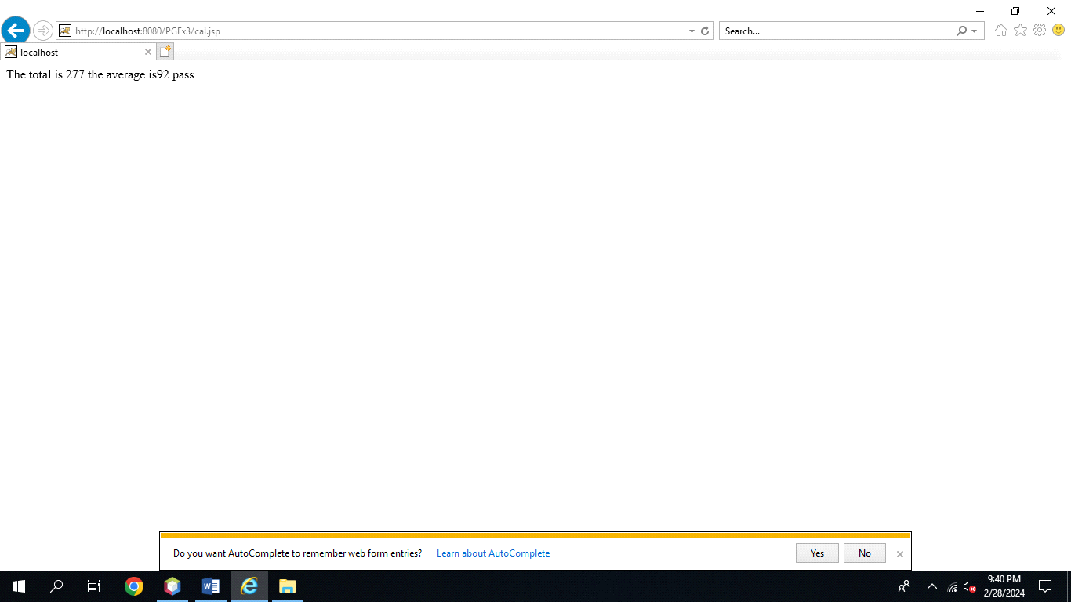

**4. Design a Purchase Order form using Html form and JSP**

**Index.html:**

<!DOCTYPE html>

<html>

<head>

<title>Purchase Order Form</title>

</head>

<body>

<h2>Purchase Order Form</h2>

<form action="PurchaseOrder.jsp" method="post">

<label for="itemName">Item Name: </label>

<input type="text" id="itemName" name="itemName" required><br><br>

<label for="quantity">Quantity: </label>

<input type="number" id="quantity" name="quantity" required min="1"><br><br>

<label for="price">Price per Unit: </label>

<input type="number" id="price" name="price" required min="0" step="0.01"><br><br>

<input type="submit" value="Submit Order">

</form>

</body>

</html>

**PurchaseOrder.jsp :**

<%@ page import="java.io.*" %>

<%@ page contentType="text/html; charset=UTF-8" %>

<%@ page language="java" %>

<html>

<head>

<title>Purchase Order Summary</title>

</head>

<body>

<h2>Purchase Order Summary</h2>

<%

// Get parameters from the form

String itemName = request.getParameter("itemName");

String quantityStr = request.getParameter("quantity");

String priceStr = request.getParameter("price");

if (itemName != null && quantityStr != null && priceStr != null) {

try {

// Parse the quantity and price to integers and doubles respectively

int quantity = Integer.parseInt(quantityStr);

double price = Double.parseDouble(priceStr);

// Calculate the total cost

double totalCost = quantity * price;

// Display the details

out.println("<p>Item Name: " + itemName + "</p>");

out.println("<p>Quantity: " + quantity + "</p>");

out.println("<p>Price per Unit: $" + price + "</p>");

out.println("<p>Total Cost: $" + totalCost + "</p>");

} catch (NumberFormatException e) {

out.println("<p>Error: Invalid number format. Please enter valid numbers for quantity and price.</p>");

}

} else {

out.println("<p>Error: Missing form data. Please fill in all the fields.</p>");

}

%>

</body>

</html>

**Output**

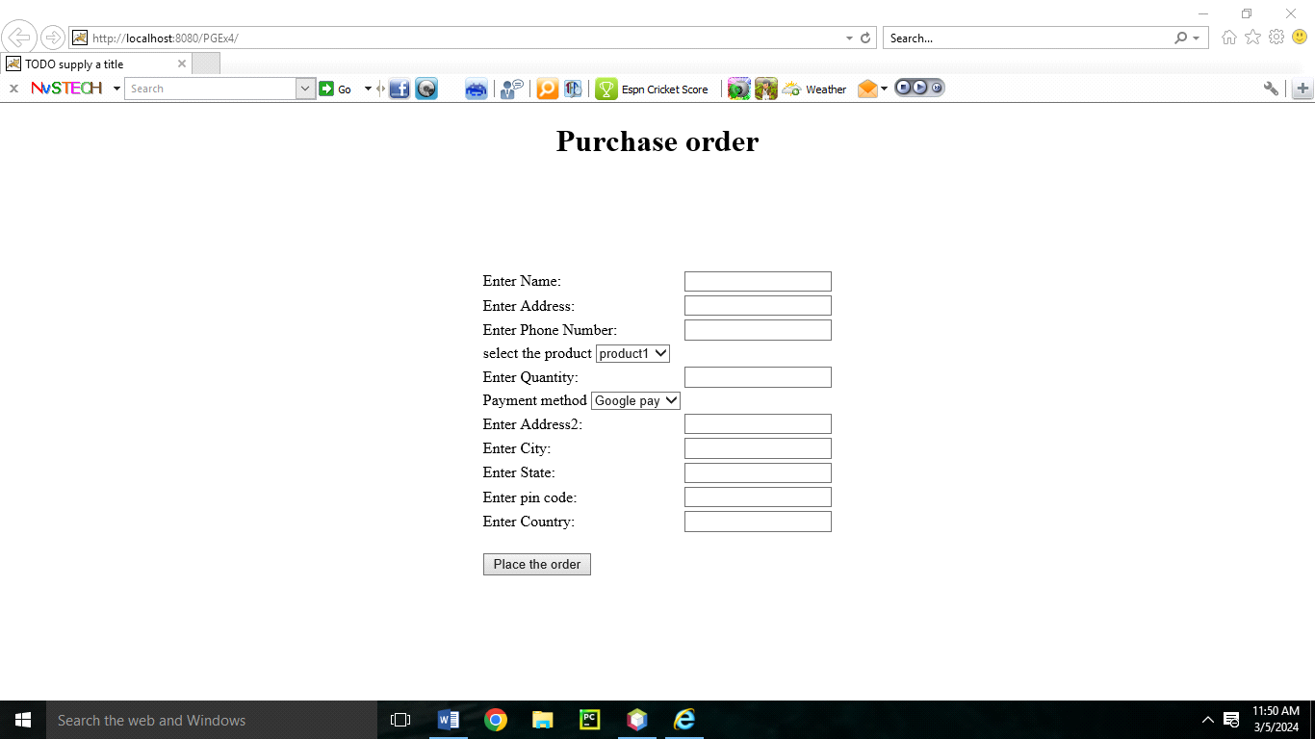

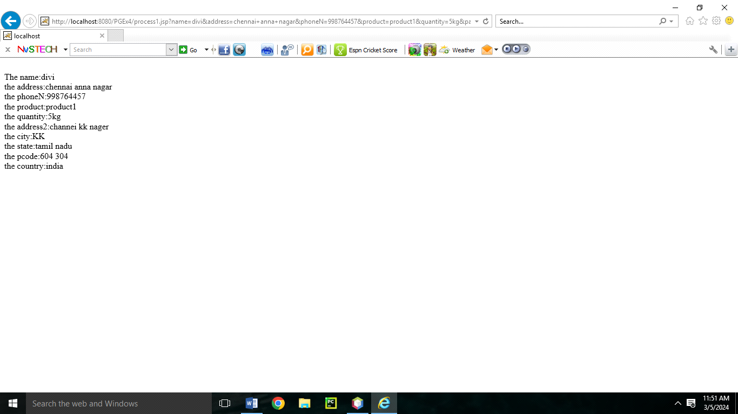

**5. Prepare a Employee payslip using JSP**

**Index.html**

<!DOCTYPE html>

<html>

<head>

<title>Employee Payslip Form</title>

</head>

<body>

<h2>Employee Payslip Form</h2>

<form action="Payslip.jsp" method="post">

<label for="employeeName">Employee Name: </label>

<input type="text" id="employeeName" name="employeeName" required><br><br>

<label for="basicSalary">Basic Salary: </label>

<input type="number" id="basicSalary" name="basicSalary" required min="0" step="0.01"><br><br>

<label for="bonus">Bonus: </label>

<input type="number" id="bonus" name="bonus" required min="0" step="0.01"><br><br>

<label for="deductions">Deductions: </label>

<input type="number" id="deductions" name="deductions" required min="0" step="0.01"><br><br>

<input type="submit" value="Generate Payslip">

</form>

</body>

</html>

**Payslip.jsp :**

<%@ page import="java.io.*" %>

<%@ page contentType="text/html; charset=UTF-8" %>

<%@ page language="java" %>

<html>

<head>

<title>Employee Payslip</title>

<style>

table {

width: 50%;

border: 1px solid black;

border-collapse: collapse;

margin: 20px 0;

}

th, td {

padding: 8px;

text-align: center;

}

th {

background-color: #f2f2f2;

}

</style>

</head>

<body>

<h2>Employee Payslip</h2>

<%

// Retrieve form data

String employeeName = request.getParameter("employeeName");

String basicSalaryStr = request.getParameter("basicSalary");

String bonusStr = request.getParameter("bonus");

String deductionsStr = request.getParameter("deductions");

if (employeeName != null && basicSalaryStr != null && bonusStr != null && deductionsStr != null) {

try {

// Parse the salary, bonus, and deductions

double basicSalary = Double.parseDouble(basicSalaryStr);

double bonus = Double.parseDouble(bonusStr);

double deductions = Double.parseDouble(deductionsStr);

// Calculate the net salary

double netSalary = basicSalary + bonus - deductions;

// Display the payslip in a table

out.println("<table>");

out.println("<tr><th>Employee Name</th><td>" + employeeName + "</td></tr>");

out.println("<tr><th>Basic Salary</th><td>$" + basicSalary + "</td></tr>");

out.println("<tr><th>Bonus</th><td>$" + bonus + "</td></tr>");

out.println("<tr><th>Deductions</th><td>-$" + deductions + "</td></tr>");

out.println("<tr><th>Net Salary</th><td>$" + netSalary + "</td></tr>");

out.println("</table>");

} catch (NumberFormatException e) {

out.println("<p>Error: Invalid number format. Please enter valid numbers for salary, bonus, and deductions.</p>");

}

} else {

out.println("<p>Error: Missing form data. Please fill in all the fields.</p>");

}

%>

</body>

</html>

**Output**

